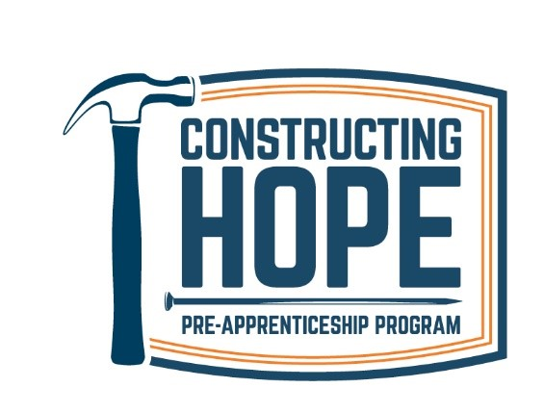

Position: Program Manager
Starting Pay: $60,000 - $70,000 annually DOE
Deadline: April 14, 2022

PROGRAM DESCRIPTION
Constructing Hope’s mission is to rebuild the lives of people in our community by encouraging self-sufficiency through skills training and education in the construction industry. We provide a no-cost, ten-week construction training program, placement services, and career advancement support. We serve minorities, people coming from incarceration, and low-income adults. A youth summer camp provides skills, motivation, and construction career pathways. Constructing Hope’s goals are to (1) help the long-term unemployed attain sustainable careers, (2) increase workforce diversity, (3) reduce recidivism, and (4) meet hiring needs in the construction industry.

THE POSITION
The Program Manager is responsible for overseeing the achievement of larger organizational goals of Constructing Hope program. The Program Manager will lead the overall program team with strong attention to strategy, implementation, and delegation. Program Manager will oversee the program operations and services that ensure students receive support services, gain the information, hard skills and soft skills with hands-on-training experience and placement aligned with their construction career goal.

ESSENTIAL FUNCTIONS
Program Management: Administrative and data management.
Responsible for maintaining and overseeing Bureau of Labor and Industries (BOLI) certification.
Maintain and communicate student data as required by funding sources.
Oversee the safety plan as directed in the policies and procedures and make sure all safety guidelines are being followed.
Ensure COVID-19 Safety protocols and implementation in the shop and classroom.
Be available for evenings and weekends on occasion; occasional out-of-town travel.
Other duties as assigned.

Curriculum and Planning.
Manage and assist the Facilitator with the development of quarterly and yearly schedule and syllabus.
Oversee curriculum with the Program Facilitator and Curriculum Committee to ensure the Bureau of Labor and Industry (BOLI) standards are in place.
Oversee and ensure coordination of Industry trades-specific hands-on training with industry partners as it relates to the schedule quarterly as well as yearly.
Work with Facilitator to identify, select, develop, and manage hands-on training projects and opportunities.
Maintain and track training inventory.
Oversee the planning of and facilitate graduation ceremonies.
Appropriately escalating and recording issues and risks and their resolution
Quality assurance disciplines for completion of project milestones

Program Management and Community Representation
Supervise, oversee, and support the Job Developers and Case Managers to ensure students are receiving the best support and information, while in the program and after graduation.
Oversee Program Facilitator and ensure all aspects of hands-on technical training including managing construction materials for each hands-on project are in place.
Facilitate various projects and steer group meetings.

Program Management: Community representation
Develop a strong network of industry partnerships to ensure adequate resources for student employment and work experiences including internships, job shadows, career guest speakers, informational interviews, etc.
Attend and participate in industry meetings, events, regular team, and staff meetings, professional development workshops, and organizational events.

Applicants Must Have:
Significant knowledge and aptitude for office technology required such as Microsoft Word, Excel, PowerPoint, Outlook, and familiarity with the use of databases.
Knowledge of construction industry safety standards and related requirements.
Minimum 2 years verifiable professional experience working in the field in the skilled trades.
Minimum 2 years’ experience as a supervisor, foreman, instructor, or person leading/organizing a group of workers.
Comfortable/competent presenting to groups of people and building strong relationships.
Able to think strategically, analyze, and work with data, and develop high quality documents.
Strong problem solving, organizational, writing, and communication skills required.
Must have great attention to detail, discretion, and a high level of accuracy and precision.
Strong time-management skills; problem-solver who can work independently and collaboratively.
Experience maintaining and supporting an inclusive workplace/jobsite environment.
Demonstrated cultural competence and experience working effectively with diverse groups of people.
HOURS & COMPENSATION
Pay range is $60,000-$70,000/annually and benefits after 30 days.
40 hours/week – 7am – 4pm.

TO APPLY
Please send your resume and cover letter indicating how you meet the Minimum Qualifications listed above to: careers@constructinghope.org

Please note: We are a drug-free program. If you are offered the job, you will be asked to have a drug screening test or other testing procedures as necessary for completion of the hiring process.

Constructing Hope is proud to be an equal opportunity employer. We are committed to an environment that welcomes and supports diversity. We seek diversity of identity, perspective, and background in our staff, board and volunteers. We strive to reflect the diversity of our community and the population we serve.
Constructing Hope is an EEP and Substance Free Workplace

